Anggota Kelompok : 1. Rofi Hareza (15.01.53.0151)

2. Arif Budi Prabowo (15.01.53.0129)

**Tugas klasifikasi menggunakan klasifikasi R**

1. Mengambil data dari

Archive.ics.uci.edu/ml/datasets.html

1. Disini kelompok kami mengambil Wholesale customer data set

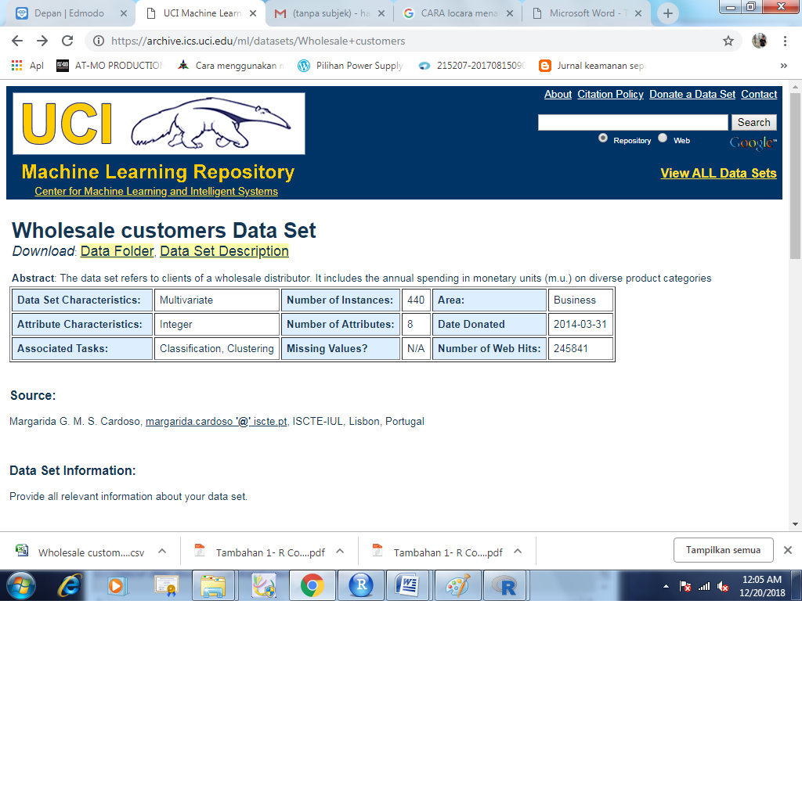

1. Lalu kita import Absenteeism_at_work ke excel.csv, kemudian kita save as dengan ekstensi Absenteeism_at_work.xlxs

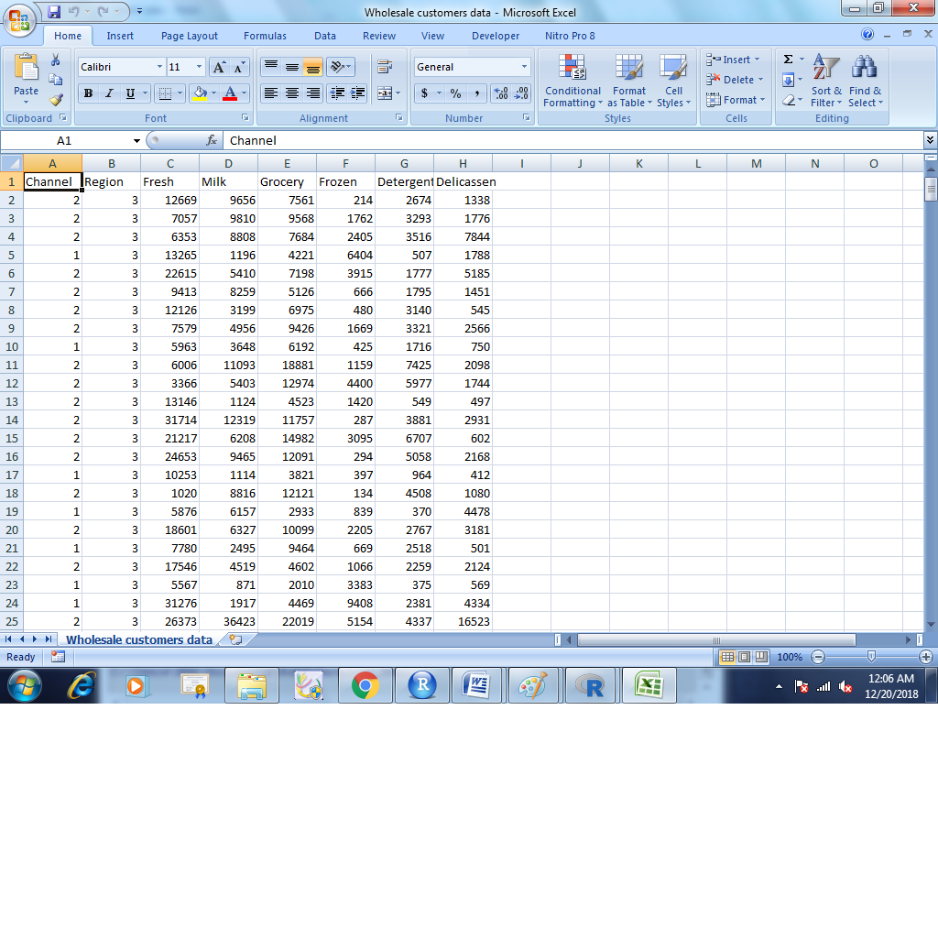

1. Lalu kita masuk ke R Comander dan menampilkan dalam bentuk dataset

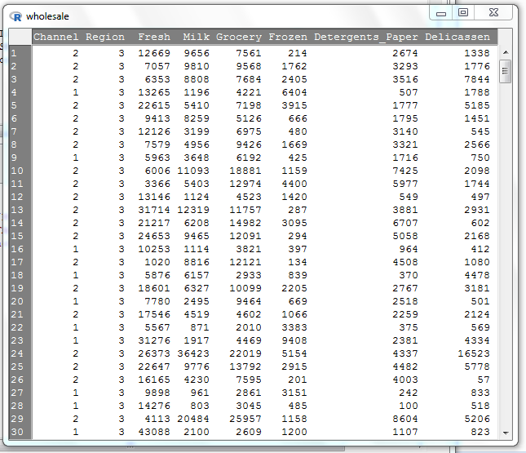

1. 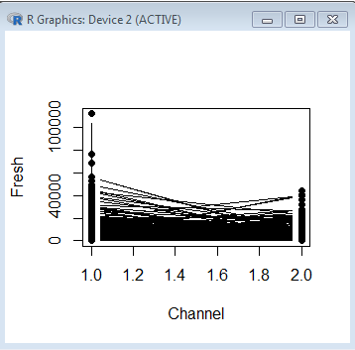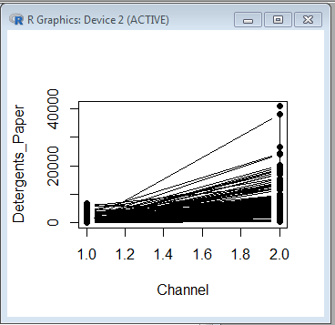Hasil klasifikasi iris data set dalam bentuk Line Graph “wholesale”

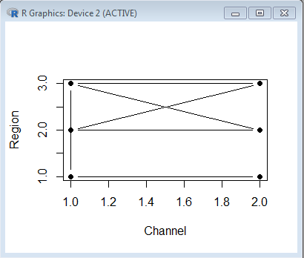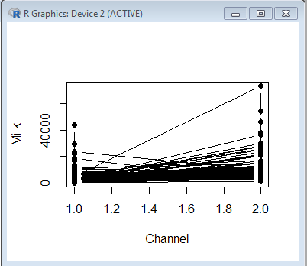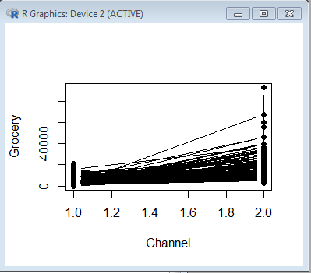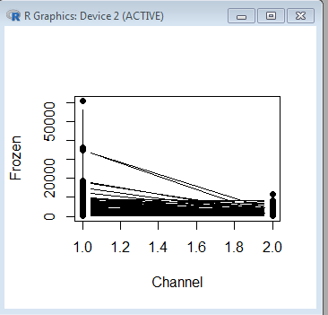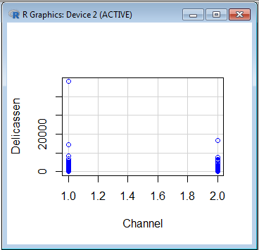

**Listing Program:**

> wholesale <-

+ readXL("G:/KULIAH/SEMESTER 7/DATAMINNING/dataminning/data/Wholesale customers data.xlsx",

+ rownames=FALSE, header=TRUE, na="", sheet="Wholesale customers data",

+ stringsAsFactors=TRUE)

> summary(wholesale)

Channel Region Fresh Milk

Min. :1.000 Min. :1.000 Min. : 3 Min. : 55

1st Qu.:1.000 1st Qu.:2.000 1st Qu.: 3128 1st Qu.: 1533

Median :1.000 Median :3.000 Median : 8504 Median : 3627

Mean :1.323 Mean :2.543 Mean : 12000 Mean : 5796

3rd Qu.:2.000 3rd Qu.:3.000 3rd Qu.: 16934 3rd Qu.: 7190

Max. :2.000 Max. :3.000 Max. :112151 Max. :73498

Grocery Frozen Detergents_Paper Delicassen

Min. : 3 Min. : 25.0 Min. : 3.0 Min. : 3.0

1st Qu.: 2153 1st Qu.: 742.2 1st Qu.: 256.8 1st Qu.: 408.2

Median : 4756 Median : 1526.0 Median : 816.5 Median : 965.5

Mean : 7951 Mean : 3071.9 Mean : 2881.5 Mean : 1524.9

3rd Qu.:10656 3rd Qu.: 3554.2 3rd Qu.: 3922.0 3rd Qu.: 1820.2

Max. :92780 Max. :60869.0 Max. :40827.0 Max. :47943.0

> library(rgl, pos=16)

> library(nlme, pos=17)

> library(mgcv, pos=17)

> with(wholesale, lineplot(Channel, Delicassen))

> scatterplotMatrix(~Delicassen+Detergents_Paper+Fresh, regLine=FALSE, smooth=FALSE, diagonal=list(method="density"),

+ data=wholesale, subset=

+ > wholesale <-

+ + readXL("G:/KULIAH/SEMESTER 7/DATAMINNING/dataminning/data/Wholesale customers data.xlsx",

+ + rownames=FALSE, header=TRUE, na="", sheet="Wholesale customers data",

+ + stringsAsFactors=TRUE)

+

+ > summary(wholesale)

+ Channel Region Fresh Milk

+ Min. :1.000 Min. :1.000 Min. : 3 Min. : 55

+ 1st Qu.:1.000 1st Qu.:2.000 1st Qu.: 3128 1st Qu.: 1533

+ Median :1.000 Median :3.000 Median : 8504 Median : 3627

+ Mean :1.323 Mean :2.543 Mean : 12000 Mean : 5796

+ 3rd Qu.:2.000 3rd Qu.:3.000 3rd Qu.: 16934 3rd Qu.: 7190

+ Max. :2.000 Max. :3.000 Max. :112151 Max. :73498

+ Grocery Frozen Detergents_Paper Delicassen

+ Min. : 3 Min. : 25.0 Min. : 3.0 Min. : 3.0

+ 1st Qu.: 2153 1st Qu.: 742.2 1st Qu.: 256.8 1st Qu.: 408.2

+ Median : 4756 Median : 1526.0 Median : 816.5 Median : 965.5

+ Mean : 7951 Mean : 3071.9 Mean : 2881.5 Mean : 1524.9

+ 3rd Qu.:10656 3rd Qu.: 3554.2 3rd Qu.: 3922.0 3rd Qu.: 1820.2

+ Max. :92780 Max. :60869.0 Max. :40827.0 Max. :47943.0

+ )

> scatterplotMatrix(~Channel+Delicassen+Detergents_Paper+Fresh+Frozen+Grocery+Milk+Region, regLine=FALSE, smooth=FALSE,

+ diagonal=list(method="density"), data=wholesale, subset=

+ > wholesale <-

+ + readXL("G:/KULIAH/SEMESTER 7/DATAMINNING/dataminning/data/Wholesale customers data.xlsx",

+ + rownames=FALSE, header=TRUE, na="", sheet="Wholesale customers data",

+ + stringsAsFactors=TRUE)

+

+ > summary(wholesale)

+ Channel Region Fresh Milk

+ Min. :1.000 Min. :1.000 Min. : 3 Min. : 55

+ 1st Qu.:1.000 1st Qu.:2.000 1st Qu.: 3128 1st Qu.: 1533

+ Median :1.000 Median :3.000 Median : 8504 Median : 3627

+ Mean :1.323 Mean :2.543 Mean : 12000 Mean : 5796

+ 3rd Qu.:2.000 3rd Qu.:3.000 3rd Qu.: 16934 3rd Qu.: 7190

+ Max. :2.000 Max. :3.000 Max. :112151 Max. :73498

+ Grocery Frozen Detergents_Paper Delicassen

+ Min. : 3 Min. : 25.0 Min. : 3.0 Min. : 3.0

+ 1st Qu.: 2153 1st Qu.: 742.2 1st Qu.: 256.8 1st Qu.: 408.2

+ Median : 4756 Median : 1526.0 Median : 816.5 Median : 965.5

+ Mean : 7951 Mean : 3071.9 Mean : 2881.5 Mean : 1524.9

+ 3rd Qu.:10656 3rd Qu.: 3554.2 3rd Qu.: 3922.0 3rd Qu.: 1820.2

+ Max. :92780 Max. :60869.0 Max. :40827.0 Max. :47943.0

+ )

> scatterplotMatrix(~Channel+Delicassen+Detergents_Paper+Fresh+Frozen+Grocery+Milk+Region, regLine=FALSE, smooth=FALSE,

+ diagonal=list(method="density"), data=wholesale, subset=

+ > wholesale <-

+ + readXL("G:/KULIAH/SEMESTER 7/DATAMINNING/dataminning/data/Wholesale customers data.xlsx",

+ + rownames=FALSE, header=TRUE, na="", sheet="Wholesale customers data",

+ + stringsAsFactors=TRUE)

+

+ > summary(wholesale)

+ Channel Region Fresh Milk

+ Min. :1.000 Min. :1.000 Min. : 3 Min. : 55

+ 1st Qu.:1.000 1st Qu.:2.000 1st Qu.: 3128 1st Qu.: 1533

+ Median :1.000 Median :3.000 Median : 8504 Median : 3627

+ Mean :1.323 Mean :2.543 Mean : 12000 Mean : 5796

+ 3rd Qu.:2.000 3rd Qu.:3.000 3rd Qu.: 16934 3rd Qu.: 7190

+ Max. :2.000 Max. :3.000 Max. :112151 Max. :73498

+ Grocery Frozen Detergents_Paper Delicassen

+ Min. : 3 Min. : 25.0 Min. : 3.0 Min. : 3.0

+ 1st Qu.: 2153 1st Qu.: 742.2 1st Qu.: 256.8 1st Qu.: 408.2

+ Median : 4756 Median : 1526.0 Median : 816.5 Median : 965.5

+ Mean : 7951 Mean : 3071.9 Mean : 2881.5 Mean : 1524.9

+ 3rd Qu.:10656 3rd Qu.: 3554.2 3rd Qu.: 3922.0 3rd Qu.: 1820.2

+ Max. :92780 Max. :60869.0 Max. :40827.0 Max. :47943.0

+ )

> scatterplot(Delicassen~Channel, regLine=FALSE, smooth=FALSE, boxplots=FALSE, data=wholesale)

> scatterplot(Delicassen~Channel, regLine=FALSE, smooth=FALSE, boxplots=FALSE, data=wholesale)

> with(wholesale, lineplot(Channel, Delicassen))

> with(wholesale, lineplot(Channel, Detergents_Paper))

> with(wholesale, lineplot(Channel, Fresh))

> with(wholesale, lineplot(Channel, Frozen))

> with(wholesale, lineplot(Channel, Grocery))

> with(wholesale, lineplot(Channel, Milk))

> with(wholesale, lineplot(Channel, Region))